

BURULLUS GAS COMPANY

WELL: Simian-Db
(Vertical Well)
WEST DELTA DEEP MARINE CONCESSION

END OF WELL REPORT

July 2012

Prepared by:
Rashid Petroleum Company
Exploration Department
18, Road 293
New Maadi
Cairo, Egypt

Well No: Simian-Db

Prepared by: Geological Operation Group

Reviewed by:....................................…………………..
M. Mubarak / S.Taman

Approved by:...................................…………………..
Jur Snijder / Heider Saad
CONTENTS

1. GENERAL
1.1 General Summary
1.2 Well Location Map
1.3 Summary of Well Data
1.4 Burullus Gas Representatives
1.5 Well Drilling Summary
1.6 Casing Summary
1.7 Survey Summary
1.8 Drilling Curve
1.9 Time Breakdown Diagram
1.10 Well Schematic

2. GEOLOGY
2.1 Prognoses versus Actual Geological Column
2.2 Stratigraphic Summary
2.3 Stratigraphy and Lithology
2.4 Hydrocarbon Summary
2.5 Pore Pressure Summary

3. CORE DATA
3.1 Coring Summary

4. PETROPHYSICAL SUMMARY
4.1 LWD Summary

ENCLOSURES

Composite Log @ 1:500 Scale

1. GENERAL

1.1 General Summary
The development well Simian-Db, a Burullus Gas Company well was operated by Rashid Petroleum Company (Rashpetco). It was drilled then plugged and abandoned using the Transocean semi-submersible ‘Amirante’ between 17th May 2012 and 27th June 2012.
Simian-Db well was the last well to be drilled as part of the West Delta Deep Marine Phase 8b development drilling program. The well is located approximately 150 km NE of Alexandria in the eastern portion of the West Delta Deep Marine concession, which lies offshore in the deep water (250-1500m) of the present day Nile Delta.
The well was originally planned in 2006 as a Phase 4 back-up well however it was not required at that time. The primary objective for the Simian-Db well is to drill and complete the Simian reservoir sands to help to address field production rate decline noted since 2009. The well was designed to penetrate thick stacked channel sands in the channel core, being in an up-dip location with a greater standoff from underlying water thus helping maximize recovery.
The major tectonic feature/control on the concession is the SW/NE trending Rosetta Fault and the NDOA anticline trending WSW/ENE and associated with normal and wrench faulting. These tectonics and Eustace have played a significant role on marine sedimentation throughout the Pliocene and Pleistocene.
Simian is one of a number of gas-bearing Upper Pliocene submarine deep water channel complexes in the West Delta Deep Marine concession and it lies near the base of the El Wastani Formation. Simian is a large 32 km long combination stratigraphic / structural trap with dip closure to the NNE and SSW and stratigraphic closure to the WNW and ESE. Simian complex comprises two main channel branches that merge to the North. These channels have basal erosion surfaces with an aggradation fill including stacked meandering channel sands encased in finer-grained overbank and levee deposits.
A vertical well was drilled to 2091mMD (-2064.45mTVDSS) in 12¼" hole where pipes get stuck. Simian-Db penetrated the Simian Channel at 2030mMD (-2003.45mTVDSS); 35.45m lower than anticipated.
Baker Hughes LWD Resistivity/Gamma ray in real time was run from 1202m to 2091m (where the drill string gets stuck). No wireline logging was planned in this well and therefore no petrophysical analysis was possible. However LWD Resistivity/GR logs show that the top 4 meters was gas bearing and the rest of the reservoir was found to be watered out.
No conventional cores or side wall cores were cut in this well.
By running the Free Point Indicator Tool it was indicated that the drill string stuck at 2049.3m. Pipes were successfully cut at 1999m with colliding tool. It was decided to plug and abandonment the well due to most of the reservoir was found to be watered out. Two cement plugs were pumped (1880 – 1625m) and (1633 – 1480m). Cement was tagged at 1479m and pressure tested to 1600psi/10min. The 13⅜″ casing was cut at 681m and pulled out then a third abandonment plug was spotted (730 – 580m).
Anchors were retrieved and the rig Amiranti was under tow from the Simian-Db location at 17:00hrs on 27th June 2012, after 41.7 days on location.
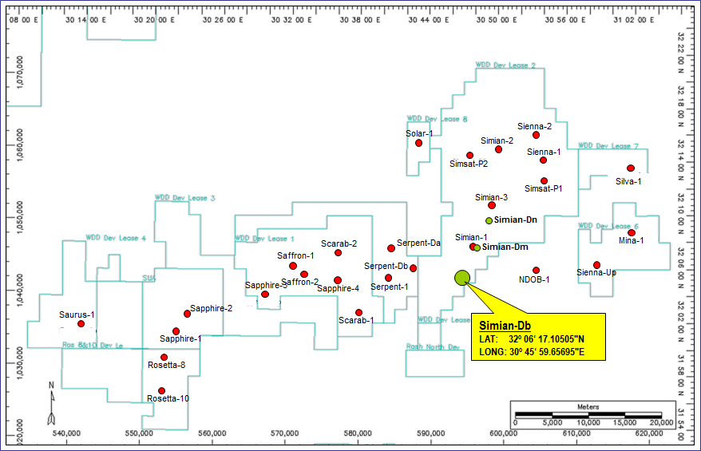
1.2 Well Location Map:

1.3 Summary of Well Data
Operator: Rashpetco for Burullus Gas Company
Partners: EGAS 50%
BG International 25%

Petronas Carigali 25%
Block: West Delta Deep Marine Concession
Well Type: Development

Area: Egypt, Offshore Nile Delta, Mediterranean Sea

Field: Simian
Surface Location: TD Location:
Lat: 32° 06' 17.12505" N Lat: 32° 06' 17.197" N
Long: 30° 45' 59.65695" E Long: 30° 45' 59.473" E
X: 592,967.470 mE X: 592,962.666 mE
Y: 1, 043,381.591 mN Y: 1, 043,383.821 mN
Projection: Egypt Red Belt TM

Spheroid: Helmert 1906
Datum: Old Egyptian 1907

(Surface Location) Inline 4871/ Xline 5754
Rig: Amirante (Semi-submersible)
Drilling Contractor: Transocean
Elevations: RTE-MSL: 26.5m

MSL-SB: 503m
RTE-SB: 529.5m
Rig on location: 17th May 2012
Spud Date: 18th May 2012
T.D. Date: 13th January 2012 (Original Hole)
23rd January 2012 (Sidetrack)
Rig off location: 7th February2012

T.D. (Driller): 2091m MD (-2064.45 m TVDSS) (BHA get Stuck)

T.D. (Logger): No wireline logs performed

T.D. Formation: El Wastani FM

Status: Plugged & Abundant (water filled)

Hole Size (Drilled Depth): 26 x 36" to 603m
26" to 1207m
17½" to 1655m
12¼" to 2091m (BHA get stuck)

Casing Depth: 36" at 598.54m
20" at 1202.5m
13⅜" at 1649.18m

1.4 Assigned Personnel

Exploration Department:

Assistant Chairman, Exploration Heider Saad Osman
Deputy Exploration General Manager Jur Snijder
Development General Manager Mohamed Mubarak
Prospect Evaluation GM Ashraf El-Amir
G&G Operations GM Nabil Shetta
Senior Geological Advisor Mark Tringham / Jena Smruti
Area Geophysicist John Luchford / Moustafa El-Sadek
Pore Pressure Prediction Mohamed Mokhtar
Area Petrophysicist M. Awad / M. Talaat
Geological Ops & Petrophysics AGM Saad Taman
Wellsite Geologists Shaker Latif / Osama Said

Operations Department:

Assistant Chairman, Operations Sabry El-Sharkawy
Operation Manager Colin White

Drilling Manager Andy Swale
Senior Drilling Engineer Kes Evoy
Wells Team Leader John Morrison
Drilling Superintendent Bob Andrew
Petroleum Eng. Gen. Mgr. Sherif Hasaballah
Petroleum Engineer Daniel De Verteuil
1.5 Well Drilling Summary:
All depths are drillers MD unless otherwise stated.

Rig Move and Anchor Running:
Anchors were pre laid and buoyed off before rig move, three anchor handling vessels involved in the operation; B Surf, B. Borgstein and Enterprise. The rig towed from Scarab Ds location to Simian Db location at 12:00 AM 17th May, 2012. Enterprise was on the main tow bridle, B. surf connected to Anchor chain No. 5 with empty decks for emergency towing. B. Borgstein connected to anchor chain No 1.
All anchors hooked up following Viking procedures. Extreme care made while hooking up anchor No.1 & No.2 to avoid damaging to subsea assets. Cross tensioned primary and secondary anchors to 360Kips.
Fine-tuned rig to final well location, took final survey, Position 1.49 m on bearing of 67.83°T from intended Well location. Ballast Rig down to normal drilling draft, adjusted anchors to working tensions on all anchors (280Kips).

Actual | NPT | Trouble Free | Pre-drill (P50) Estimate
1.5 days | 0.0 days | 1.5 days | 2.59 days

Drilling 36"Hole (529.5 - 603m):
BHA made up and RIH offline while ballasting down rig to drilling draft. Tagged seabed at 529.5m, water depth 503m (planned 503m). Spud Simian DB well at 11:25 8th May, 2012, drilled ahead 36’’ hole with 700gpm increased gradually to 900gpm/1300psi to 580m. Increased FR to 1200gpm/2700psi, drilled ahead to 603m.
New displacement technique: displaced hole with 600bbls 12.0ppg kill mud by mixing one pit of 16ppg with 1 pit of seawater on the fly through 2 pumps. Survey at TD showed 1.35° inclination decreased to 1.11° with back reaming. Pumped out of hole with 330 gpm, 100 psi (150 gpm 16 ppg mud and 180 gpm, sea water), Hole in good condition.
Actual | NPT | Trouble Free | Pre-drill (P50) Estimate
0.9 days | 0.0 days | 0.9 days | 0.5 days

Running & Cementing 30"Conductor:
Conductor was run to 598m without issues. Stinger to shoe 16.7 m. Wellhead stick up 3.5m as per plan, RGB heading 330°, recorded bulls eyes reading, FWD = 0.0° and STB=3/4° @ 190°.
Performed cement job; Mixed and pumped 290 bbl. of 12ppg class ‘C’ cement based on 300% excess. Final circulating pressure 240psi. Displaced with 50bbl sea water .Good returns throughout job, cement first seen after 280 bbl. pumped, calculated hole diameter based on cement returns 42.53’’.
Tried to tag cement in the annulus, no cement encountered after 27m. Performed top up job using 14.5ppg thixotropic slurry. Mixed and pumped 300 bbl. of 14.5 ppg class 'G' cement thixotropic slurry followed by 10 bbl. sea water.
Perform another top up job after 20’’ casing using 14.5ppg thixotropic slurry. Mixed and pumped 180 bbl. of 14.5 ppg class 'G' cement thixotropic slurry followed by 20 bbl. sea water.

Actual | NPT | Trouble Free | Pre-drill (P50) Estimate
1.6 days | 0.3 days | 1.3 days | 2.5 days

Drilling 26" Hole (603 - 1207m):
Tagged TOC at 591.5m (2.5m deeper than theoretical). Drilled firm good cement in shoe track. No cement in rat hole, no change in bulls eyes reading after drilling shoe track.
Drilled ahead 26’’ hole from 603m to 1207 . Had to control ROP from 1,115 m to 1,135 m due to leak in mud pump No.1 pop off.
Displaced hole to 12.0ppg kill mud with 1000gpm/3000psi. Pumped out of hole from 1207m section TD to 30’’ casing shoe, 25 ¾’’ stabilizer totally balled up, cleaned with ROV, ran back on elevators, worked tight spots encountered, washed down with 150gpm/0psi. Tagged 20m fill, washed same. Displaced hole with 12.0ppg kill mud, POOH on elevators, tight spots encountered with 40K over pull, back reamed from 1192 m to 1153 m.

Actual | NPT | Trouble Free | Pre-drill (P50) Estimate
3.6 days | 0.0 days | 3.6 days | 2.9 days

Running & Cementing 20" Casing:
Casing was run without problems. Stinger to shoe 20m. 18 ¾’’ HPWHH landed on LPWHH without problems. Performed cement job; pumped 800 bbl. of 12.5ppg lead slurry based on 100% excess followed by 363 bbl. of 15.8ppg tail slurry based on 100% excess for tail slurry. Displaced cement with 80 bbl. of sea water with differential pressure of 550psi. Cement was tagged on depth 1192m with 10K.

Actual | NPT | Trouble Free | Pre-drill (P50) Estimate
1.4 days | 0.0 days | 1.4 days | 1.5 days

Running & testing the BOP:
BOP and marine riser were run with minor problems. Changed out third slick joint due to damaged insert. Suspended operation some hours for travelling block and crown block inspection. BOP latched without problems. Diverter landed in place and function tested.

Actual | NPT | Trouble Free | Pre-drill (P50) Estimate
3.0 days | 0.3 days | 2.7 days | 2.2 days

Drilling 17½ " Hole (1207 -1655m):
RIH with 17.5’’ BHA to wellhead. Made several attempts to pass 18 ¾’’ NSP. Tagged cement at 1192m with 10K down. Displaced hole to 10.2ppg mud. MWD signal lost and BCPM not responding. Drilled very hard cement in shoe track, performed LOT; surface pressure 218psi with EMW of 11.27ppg. This will provide 25 bbl. kick tolerance sufficient to drill ahead this section to TD with no need for 16’’ liner.
Drilled ahead 17.5’’ hole controlling ROP due to mud pump No.1 failure in discharge module. Drilled almost the whole section without boosting riser. Circulated bottom’s up with 1000gpm/2700psi, boosted riser using cement unit with 335gpm. Tried to POOH on elevators, 50K over pull encountered back reamed out of hole from 1625m.

Actual | NPT | Trouble Free | Pre-drill (P50) Estimate
5.1 days | 1.0 days | 4.1 days | 3.3 days

Running & Cementing 13⅜" Casing:
Casing was run with minor issues due to unusable primary CHSART, switched to backup one. Landed 13 3/8’’ Hanger without problems. Circulated 150% casing volume. Performed cement job; pumped 85 bbl. of 15.8ppg class ‘G’ cement. Top plug sheared with 2000 psi after 21 bbl. (100 stks early due to vacuum of cement). Plug pumped 59 stks early for pump efficiency 97%. Casing tested to 3000 psi for 15 min.

Actual | NPT | Trouble Free | Pre-drill (P50) Estimate
3.4 days | 0.7 days | 2.7 days | 2.0 days

Drilling 12¼" Hole (1655 - 2091m):
Hard cement tagged at 1623m (on depth). Performed LOT; EMW=13.3ppg with surface pressure 760psi higher than expected (12.3ppg EMW with 480psi surface pressure). Hazard 1 avoided in trajectory (120m to NE). Depleted sand lenses from 1710m to 1717m. Reservoir top encountered 35m deeper than planned at 2030m. Severe losses (300bph) encountered at 2039.5m. Spotted 97bbl of 39ppb LCM pill, losses cured then slowly recurring during drilling (48bph). Losses reduced to zero at 2081m. Drilled ahead to 2091m. Severe losses encountered. Flow checked; losses at 120bph. Got mechanically stuck at 17:30 10th June, 2012 with bit at 2081 (10m off bottom).
Reasons for stuck: cuttings avalanche because of: caving noted in shakers before stuck. Pore pressure 10.3ppg at 1900m with MW only 10.55ppg. Unable to increase mud weight due to losses so hole packed off.
Several attempts to free stuck pipe with jarring up with 100K and down with 90K without success. No returns while circulating with no increase in SPP due to loss zone. Pumped 100bbls of 80ppb LCM and 100bbls of 160ppb LCM and 50bbl of Hydro Plug pill, losses not cured and still have no return and no increase in SPP.
Ran FPIT, indicated stuck at 2049.3m (well commander depth). Isolated reservoir by pumping dart, landed same at MWD with no increase in SPP. Pumped 2.5’’ well commander ball to close bypass ports, tested to 1600psi. Performed drift run with CCL tool, decided to cut at the drill collar below jar. Successfully cut at 1999m with colliding tool. No losses encountered after cut. No gas encountered while circulating. POOH with some over pull.
Left in hole: 12-1/4" bit, 12-1/8" NBS, 8" F/S, 9-1/2" OTK, X/O, 8-1/4" TTK, 11-3/4" STB, 8-1/2" Well Commander, 9 x 8-1/4" DC, fired off 8-1/4" DC.

Actual | NPT | Trouble Free | Pre-drill (P50) Estimate
9 days | 4.9 days | 4.1 days | 4.8 days

Plug and abandonment:
Plug and abandonment decided due to poor reservoir show while drilling not due to stuck pipe so there was no need to side track the well for extremely depleted sand.
Ran with 3.5’’ stinger, tight spots encountered from 1866m to 1880m. Decision made not to pass 1880m. Mixed and pumped first plug (1880 – 1625) with 30% open hole excess. Plug tagged at 1633m with 10K. Plug tested to 1300psi/10min. pumped second plug (1633-1480) with no excess. Plug tagged at 1479m and pressure tested to 1600psi/10min.
13 3/8’’ casing cut at 681m without issues. No gas or losses encountered after cut. Retrieved 13 3/8’’ casing with seal assembly and hanger in one go with casing spears without problems. Spotted VRP from 830m to 730m. Spotted third abandonment plug (730 – 580) with zero excess, this plug is 50m inside 13 3/8’’ casing and 100m inside 20’’ casing. Plug tagged at 585.5m with 10K and inflow tested.
Pulled BOP and marine riser without issues. HPWHH and LPWHH were cut with minor problems. Changed out cutters. Pulled guide posts. Pulled drilling guide base and wellhead.

Actual | NPT | Trouble Free | Pre-drill (P50) Estimate
7.6 days | 6.5 days | 1.1 days | 1 days

1.6 Casing Summary:
Casing | Hole Size  (in) | Casing  (in) | Wt  (lbs/ft) | Grade | Coupling | Depth  (mbrt)
Conductor | 26 x 36 | 30 | 456/310 | X-56 | D90/D60 | 598.54
Surface | 26 | 20 | 129 | X-56 | E60/RL-4S | 1202.5
Intermediate | 17½ | 13⅜ | 72 | P110 | BTC | 1649.18

1.7 Survey Summary
The Simian-Db well was a vertical well; MWD surveys indicated the maximum deviation was 1.46° at 570m. . The total wellbore displacement at 2066.0m – the last survey before TD - was 2.16m from wellhead coordinates in the North direction.
Measured Depth (mbrt) | Incl  (deg) | Azimuth  (deg) | Vertical  Depth  (mbrt) | Horizontal  Co-ordinates (m)  +-N/S +-EW | Vertical  Section  (m) | Dogleg  Severity  (deg/30m)

0.0 | 0.00 | 107.57 | 516 | 0.00 | 0.00 | 0.00 | 0.00
26.5 | 0.00 | 107.57 | 516 | 0.00 | 0.00 | 0.00 | 0.00
516 | 0.15 | 107.57 | 516 | -0.21 | 0.66 | -0.21 | 0.009
530 | 0.87 | 356.58 | 530 | -0.11 | 0.67 | -0.11 | 2.016
541 | 0.87 | 14.25 | 541 | 0.06 | 0.69 | 0.06 | 0.733
555 | 1.08 | 44.76 | 555 | 0.25 | 0.81 | 0.25 | 1.184
565 | 0.85 | 84.01 | 564.99 | 0.33 | 0.95 | 0.33 | 2.054
570 | 1.46 | 64.22 | 569.99 | 0.36 | 1.04 | 0.36 | 4.317
577 | 1.35 | 32.77 | 576.99 | 0.47 | 1.17 | 0.47 | 3.297
587 | 1.29 | 61.59 | 586.99 | 0.62 | 1.33 | 0.62 | 1.981
591 | 1.11 | 50.12 | 590.99 | 0.67 | 1.4 | 0.67 | 2.208
645 | 0.24 | 96.48 | 644.98 | 0.99 | 1.91 | 0.99 | 0.536
674 | 0.46 | 74.67 | 673.98 | 1.02 | 2.09 | 1.02 | 0.263
702 | 0.22 | 30.66 | 701.98 | 1.09 | 2.22 | 1.09 | 0.365
731 | 0.21 | 83.22 | 730.98 | 1.15 | 2.3 | 1.15 | 0.194
760 | 0.25 | 350.35 | 759.98 | 1.21 | 2.34 | 1.21 | 0.342
788 | 0.31 | 21.24 | 787.98 | 1.34 | 2.36 | 1.34 | 0.174
817 | 0.44 | 87.67 | 816.98 | 1.42 | 2.5 | 1.42 | 0.437
845 | 0.49 | 124.27 | 844.98 | 1.36 | 2.71 | 1.36 | 0.314
873 | 0.38 | 95.37 | 872.98 | 1.29 | 2.89 | 1.29 | 0.258
902 | 0.22 | 68.1 | 901.98 | 1.3 | 3.04 | 1.3 | 0.212
931 | 0.13 | 197.28 | 930.98 | 1.29 | 3.08 | 1.29 | 0.328
959 | 0.09 | 173.85 | 958.98 | 1.24 | 3.08 | 1.24 | 0.06
987 | 0.22 | 275.62 | 986.98 | 1.22 | 3.03 | 1.22 | 0.271
1016 | 0.33 | 222.24 | 1015.98 | 1.16 | 2.92 | 1.16 | 0.273
1045 | 0.28 | 212.04 | 1044.98 | 1.04 | 2.82 | 1.04 | 0.072
1073 | 0.37 | 279.16 | 1072.98 | 1 | 2.7 | 1 | 0.395
1102 | 0.31 | 298.45 | 1101.98 | 1.05 | 2.54 | 1.05 | 0.134
1130 | 0.59 | 257.58 | 1129.98 | 1.05 | 2.33 | 1.05 | 0.44
1158 | 0.49 | 250.51 | 1157.98 | 0.98 | 2.07 | 0.98 | 0.127
1187 | 0.59 | 245.08 | 1186.97 | 0.88 | 1.82 | 0.88 | 0.117
1198 | 0.07 | 136.79 | 1197.97 | 0.85 | 1.77 | 0.85 | 1.689
1227 | 0.53 | 264.73 | 1226.97 | 0.82 | 1.65 | 0.82 | 0.592
1256 | 0.47 | 270.28 | 1255.97 | 0.81 | 1.4 | 0.81 | 0.08
1284 | 0.49 | 262.77 | 1283.97 | 0.8 | 1.17 | 0.8 | 0.071
1312 | 0.49 | 261.28 | 1311.97 | 0.76 | 0.93 | 0.76 | 0.014
1341 | 0.43 | 274.32 | 1340.97 | 0.75 | 0.7 | 0.75 | 0.122
1370 | 0.44 | 290.34 | 1369.97 | 0.8 | 0.49 | 0.8 | 0.126
1398 | 0.5 | 297.23 | 1397.97 | 0.89 | 0.28 | 0.89 | 0.085
1427 | 0.62 | 299.87 | 1426.97 | 1.03 | 0.03 | 1.03 | 0.126
1455 | 0.69 | 307.88 | 1454.96 | 1.21 | -0.23 | 1.21 | 0.125
1484 | 0.58 | 301.85 | 1483.96 | 1.39 | -0.49 | 1.39 | 0.133
1512 | 0.5 | 302.17 | 1511.96 | 1.53 | -0.72 | 1.53 | 0.088

Measured Depth (mbrt) |  | Incl  (deg) | Azimuth  (deg) |  | Vertical  Depth  (mbrt) | Horizontal  Co-ordinates (m)  +-N/S +-EW |  | Vertical  Section  (m) | Dogleg  Severity  (deg/30m)
1541 | 0.43 |  |  | 294.4 | 1540.96 | 1.64 | -0.92 | 1.64 |  | 0.096
1569 | 0.37 |  |  | 285.16 | 1568.96 | 1.71 | -1.1 | 1.71 |  | 0.091
1598 | 0.42 |  |  | 276.34 | 1597.96 | 1.74 | -1.3 | 1.74 |  | 0.079
1626 | 0.47 |  |  | 269.15 | 1625.96 | 1.75 | -1.52 | 1.75 |  | 0.081
1644 | 0.53 |  |  | 251.16 | 1643.96 | 1.73 | -1.67 | 1.73 |  | 0.278
1667 | 0.17 |  |  | 254.74 | 1666.96 | 1.68 | -1.8 | 1.68 |  | 0.464
1695 | 0.22 |  |  | 264.51 | 1694.96 | 1.67 | -1.9 | 1.67 |  | 0.059
1724 | 0.26 |  |  | 281.54 | 1723.96 | 1.67 | -2.02 | 1.67 |  | 0.088
1753 | 0.25 |  |  | 280.14 | 1752.96 | 1.7 | -2.14 | 1.7 |  | 0.02
1781 | 0.3 |  |  | 273.3 | 1780.96 | 1.71 | -2.28 | 1.71 |  | 0.07
1810 | 0.31 |  |  | 279.67 | 1809.96 | 1.73 | -2.43 | 1.73 |  | 0.035
1838 | 0.35 |  |  | 279.39 | 1837.96 | 1.76 | -2.59 | 1.76 |  | 0.046
1866 | 0.39 |  |  | 283.91 | 1865.96 | 1.8 | -2.77 | 1.8 |  | 0.052
1895 | 0.4 |  |  | 281.97 | 1894.95 | 1.84 | -2.96 | 1.84 |  | 0.021
1923 | 0.47 |  |  | 279.62 | 1922.95 | 1.88 | -3.17 | 1.88 |  | 0.068
1952 | 0.49 |  |  | 278.15 | 1951.95 | 1.92 | -3.41 | 1.92 |  | 0.031
1980 | 0.5 |  |  | 285.55 | 1979.95 | 1.97 | -3.65 | 1.97 |  | 0.07
2009 | 0.56 |  |  | 281.12 | 2008.95 | 2.03 | -3.91 | 2.03 |  | 0.067
2066 | 0.6 |  |  | 285.93 | 2065.95 | 2.16 | -4.47 | 2.16 |  | 0.037

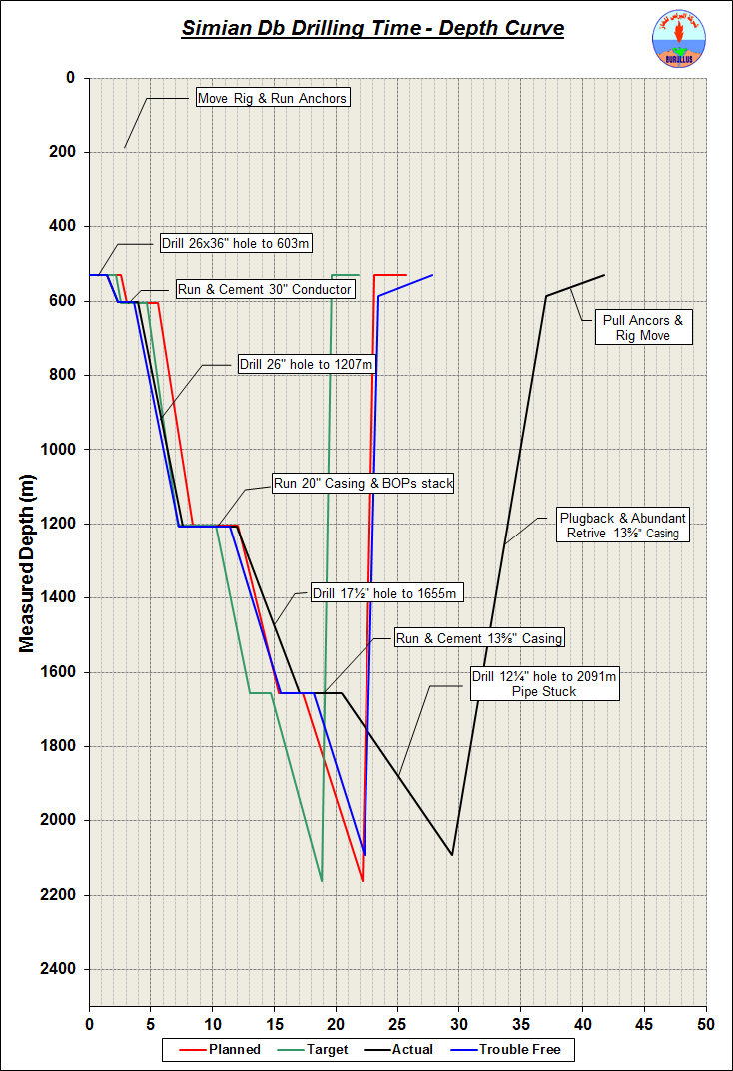
1.8 Drilling Curve
1.9 Time Breakdown Diagram:
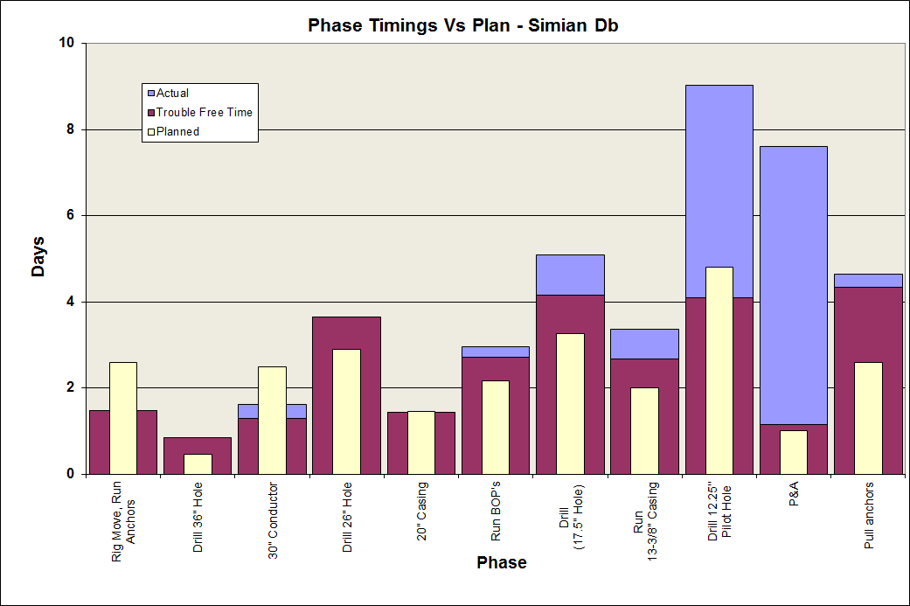

Simian-Ds
NPT Phase Chart

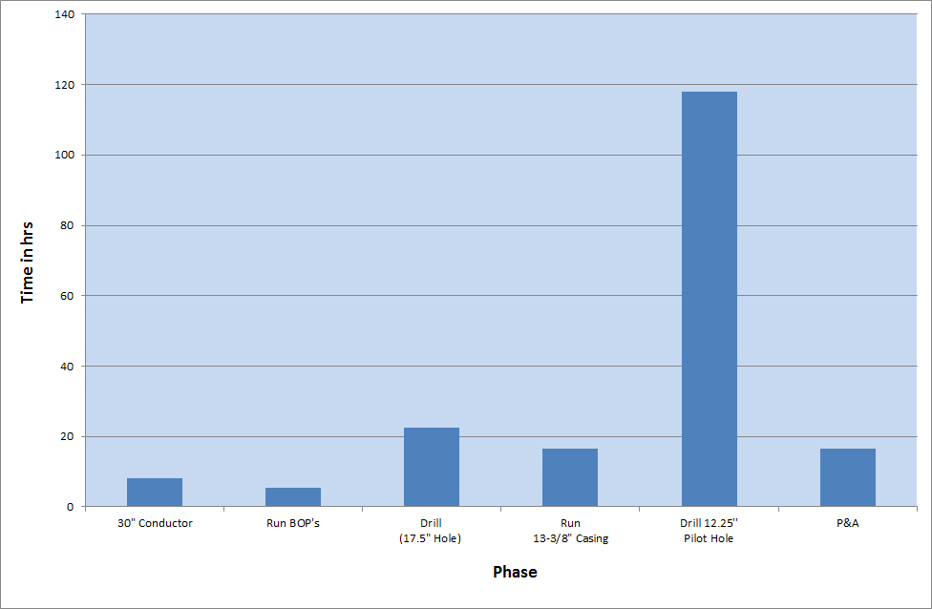
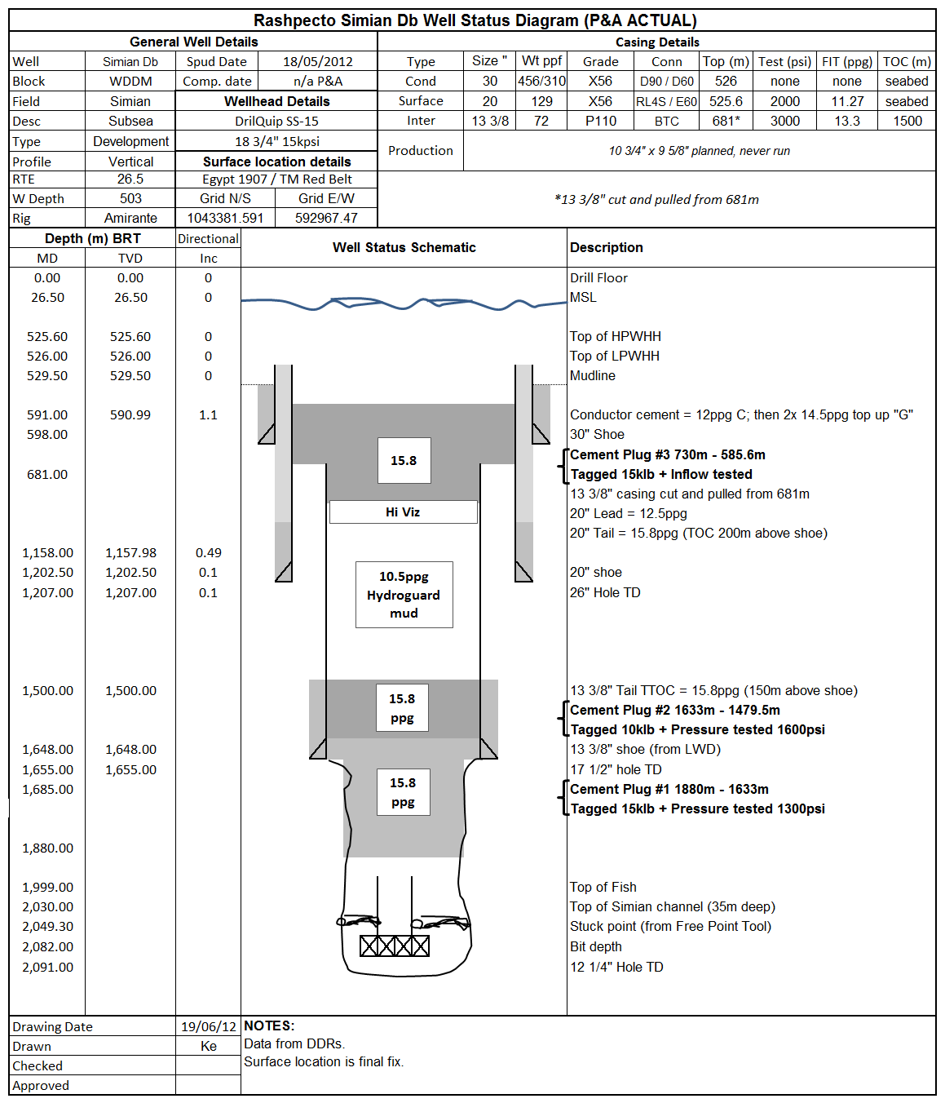
  - Well Schematic:

- GEOLOGY

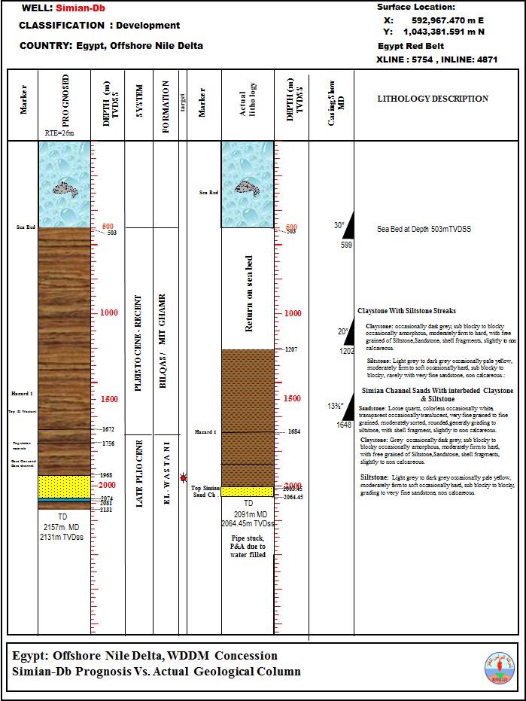
2.2 Prognoses versus Actual Geological Column
2.2 Stratigraphic Summary
A summary of the stratigraphic intervals is listed below. The intervals are based on LWD .

Biostratigraphy analysis done for the well.
Formation/Marker | m MD | m TVDSS | m Hi/Low  to prog | Pick
Bilqas/Mit Ghamr (Seabed) | 529.2 | 503 | - | Sea Bed
EL WASTANI FORMATION | 1210 | 1183.5 | - | Biostrata
EARLY PLEISTOCENE-LATE PLIOCENE | 1915 | 1888.5 | - | Biostrata
Simian Channel (Top) | 2030.2 | 2004 | 36L | LWD
Simian Channel (Base) | 2092.2 | 2066 | 8 H | LWD
Total Depth (Driller) | 2092 | 2066 | 65H | Driller

2.3 Stratigraphy and Lithology
First returns to surface were obtained from the start of the 17½" section at 1207m, with a 10m-sampling interval. Samples were collected in 5m-sampling interval from depth 1655m to well TD. All depths quoted are LWD unless otherwise stated.

Resent - Late Pleistocene
Bilqas & Mit Ghamr Formation
529.5m to 1207m MD (503.0 to 1180.47mTVDSS)
The 36" and 26" hole sections were drilled riser less, no cuttings description was possible and thus direct lithological identification of the formation could not be made; though soft, sticky, hydrophilic dark gray Claystone are the expected lithology.

(First Returns from 1207m)

17½" Hole Section

1207m – 1210m Mainly Claystone:
Claystone: Grey, dark grey, occasionally light grey, blocky to sub blocky, soft to moderate firm, occasionally hard, slightly calcareous.

1210m – 1350m mainly consist of Claystone and Siltstone:
Claystone: Grey, dark grey, occasionally light grey, blocky to sub blocky, soft to moderate firm, occasionally hard, slightly calcareous with free grains of siltstone, microfossils and shell fragments.
Siltstone: Grey to pale yellow, occasionally dark grey, blocky to sub blocky, moderate firm to hard, slightly calcareous to non-calcareous, rarely grading to very fine sandstone.

1350m – 1520m mainly consist of Claystone and Siltstone:
Claystone: Grey, dark grey, occasionally light grey, blocky to sub blocky, moderate firm, hard, slightly calcareous with free grains of siltstone, microfossils and shell fragments.
Siltstone: Grey to pale yellow, occasionally dark grey, blocky to sub blocky, moderate firm to hard, slightly calcareous to non-calcareous, rarely grading to very fine sandstone.

1520m – 1655m mainly consist of Claystone and Siltstone:
Claystone: Grey, dark grey, occasionally light grey, blocky to sub blocky, occasionally flaky, moderate firm, hard, slightly calcareous with free grains of siltstone, microfossils and shell fragments.
Siltstone: Grey to pale yellow, occasionally dark grey, blocky to sub blocky, moderate firm to hard, slightly calcareous to non-calcareous, rarely grading to very fine sandstone.

12¼" Hole Section

1655m – 1735m mainly consist of Claystone, Siltstone and Sandstone Streaks:
Claystone: Grey, dark grey, occasionally light grey, blocky to sub blocky, occasionally flaky, moderate firm, hard, slightly calcareous with free grains of siltstone, microfossils and shell fragments.
Siltstone: Grey to pale yellow, occasionally dark grey, blocky to sub blocky, moderate firm to hard, slightly calcareous to non-calcareous, rarely grading to very fine sandstone.
Sandstone: Loose quartz, colorless occasionally white, transparent occasionally translucent, fine grained occasionally medium, moderately to good sorted, sub rounded, sub angular.

1735m – 2010 Mainly Claystone and Siltstone intercalation:
Claystone: Grey, dark grey, occasionally light grey, blocky to sub blocky, occasionally flaky, moderate firm, hard, slightly calcareous with free grains of siltstone, microfossils and shell fragments.
Siltstone: Grey to pale yellow, occasionally dark grey, blocky to sub blocky, moderate firm to hard, slightly calcareous to non-calcareous, rarely grading to very fine sandstone.

2010m – 2032m Claystone and Siltstone intercalation with Sandstone Streaks:
Claystone: Grey, dark grey, occasionally light grey, blocky to sub blocky, occasionally flaky, moderate firm, hard, slightly calcareous with free grains of siltstone, microfossils and shell fragments.
Sandstone: Loose quartz, colorless occasionally white, pale yellow, transparent occasionally translucent, fine to medium grained, occasionally coarse, moderately to good sorted, sub rounded, sub angular with semi-cemented aggregates of fine grained sandstone.
Siltstone: Grey to pale yellow, occasionally dark grey, blocky to sub blocky, moderate firm to hard, slightly calcareous to non-calcareous, rarely grading to very fine sandstone.

2046m – 2086m this interval mainly consist of Claystone and Sandstone, Siltstone:
Claystone: Grey, dark grey, occasionally light grey, blocky to sub blocky, occasionally flaky, moderate firm, hard, slightly calcareous with free grains of siltstone, microfossils and shell fragments.
Sandstone: Loose quartz, colorless occasionally white, pale yellow, transparent occasionally translucent, medium to coarse grained, occasionally fine, moderately sorted, sub rounded, sub angular.
Siltstone: Grey to pale yellow, occasionally dark grey, blocky to sub blocky, moderate firm to hard, slightly calcareous to non-calcareous, rarely grading to very fine sandstone.

2.4 Hydrocarbon Summary
Type of Gas | Depth Interval (mbrt) | Total  (%) | C1  (ppm) | C2  (ppm) | C3  (ppm) | TotC4  (ppm) | C5  (ppm)
Average Gas | 1207 - 1350 | 0.18 | 1517 | 0 | 0 | 0 | 0
Average Gas | 1350 - 1520 | 0.14 | 885 | 0 | 0 | 0 | 0
Average Gas | 1520 - 1655 | 0.18 | 1240 | 0 | 0 | 0 | 0
Average Gas | 1655 - 1735 | 0.09 | 254 | 0 | 0 | 0 | 0
Average Gas | 1735 - 2010 | 0.09 | 600 | 0 | 0 | 0 | 0
Average Gas | 2010 - 2032 | 0.11 | 489 | 0 | 0 | 0 | 0
Average Gas | 2046 - 2086 | 0.09 | 434 | 0 | 0 | 0 | 0
Peak Drilled Gas | 1264.5 | 0.28 | 2671 | 0 | 0 | 0 | 0
Peak Drilled Gas | 1377.5 | 0.20 | 1763 | 0 | 0 | 0 | 0
Peak Drilled Gas | 1622.5 | 0.32 | 1881 | 0 | 0 | 0 | 0
Peak Drilled Gas | 1655.5 | 0.15 | 593 | 0 | 0 | 0 | 0
Peak Drilled Gas | 1840.5 | 0.19 | 739 | 0 | 0 | 0 | 0
Peak Drilled Gas | 2018.5 | 0.20 | 671 | 0 | 0 | 0 | 0
Peak Drilled Gas | 2080 | 0.14 | 797 | 0 | 0 | 0 | 0

Intervals from 2032 – 2046m and 2086 – 2091m were lost in hole due to Mud losses and pipes stuck.

2.5 Pore pressure Summary
The Sperry-Sun PP/FG real time predicting Pore Pressure and Fracture Gradient was used started from the 17½ x 20" hole at 1207m where the LWD resistivity and gamma ray were available as real time. The PP/FG™ uses an effective stress approach to calculate formation pressures through all major sedimentary lithology. The model was calibrated using the data from offset wells.
For the most optimum accuracy to achieve this job the corrected dc exponent (dxc) was also processed and used as a secondary tool. It was fairly useful especially in missed LWD data intervals as well as intervals of hydrocarbon bearings to compensate for high hydrocarbon effect.
17½ x 20" Hole (1207– 1655m TVD):
The recorded LOT was 11.3 ppg EMW at 1202 m.
The PP/FG model showed a gradual increasing in pore pressure through the clay stone section of the late Pliocene from 9.2ppg EMW at 1207m TVD to 10.08ppg EMW as the maximum value at 1513m TVD. Interval from 1513m TVD to 1655m TVD, the pore pressure showed a cycle of increasing and decreasing with minimum value of 9.45ppg at1592m TVD while the maximum value was 9.93ppg at 1648m TVD which was the last data from LWD tools in this hole section
The background gas during drilling this hole was averaging 0.04% and the maximum was 0.32% at 1622.5m.The hole condition was in good shape .No over pull experienced at connections and no connection gas
12¼" Hole (1655– 2092m TVD):
The recorded LOT was 13.3 ppg EMW at 1648 m.
The PP/FG model showed a gradual increasing and decreasing in pore pressure gradient through the clay stone section of the late Pliocene from 9.9ppg EMW at 1655m TVD to 9.7ppg EMW at 2029m TVD and the maximum pore pressure gradient reading in this hole was 10.3ppg EMW at 1936m TVD, the model showed pore pressure of 9.58ppg EMW at top of the reservoir and had 9.33ppg EMW at 2084m TVD which was the last LWD data of this hole. No connection gases or pump off gases recorded in this hole
Post well analysis
The PPFG model has been re-run again by Sperry sun to check the accuracy of the PPFG and it was found that it indicating a lower pore pressure magnitude in the deeper section than it was expected by the analysis done in Rashpetco office and confirmed by the post well pore pressure analysis using Sonic (DTCO) and deep resistivity from wire line logs which has indicated an increase in pore pressure trend in the deeper section above reservoir.

LOT Summary
Depth - MD | LOT / FIT | Comment
m | PPGE | Comment
1202 | 11.3 | LOT
1648 | 13.3 | LOT

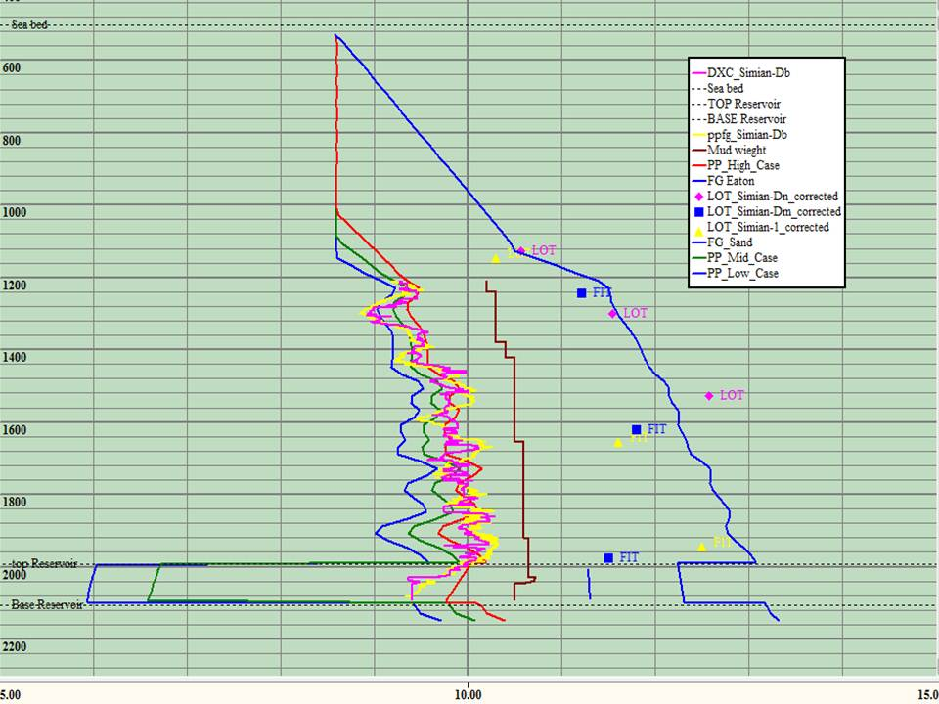

Depth TVD,m
Simian-Db analysis (Pore pressure & Fracture gradient(
Pore Pressure, ppg

3. CORE DATA

3.1 Coring Summary:
No conventional cores or side wall cores were taken in this well.

4. PETROPHYSICAL SUMMARY

4.1 Logging Summary

4.1.1 LWD Logging Summary
Run No. | LWD Logging Services | Log  Interval | Date run completed | Max  Temp
 | 17½" hole
1 | Gamma Ray/Resistivity (OnTk) | 1202 – 1649m | 02-June-2012 | 101°F
 | 12¼" hole
2 | Gamma Ray/Resistivity (OnTk) | 1649 – 2091m | Left in hole
** No recorded data available for the 12¼" hole due to BHA stuck at 2091m and leaving tools down hole.

4.1.2 Wireline Logging Summary
Wireline logging program was cancelled due to getting the BHA stuck at 2091m before reaching the final TD and the decision was made to abandon the well.

